- Download the data set in kaggle website
Data set Link : https://www.kaggle.com/datasets/rahulmenon1758/car-resale-prices

- Import the dataset in Excel and start cleaning work

1. Serial Number Change

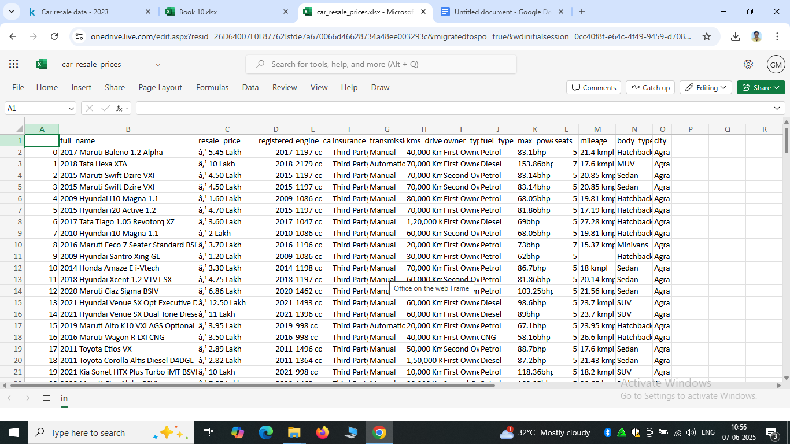

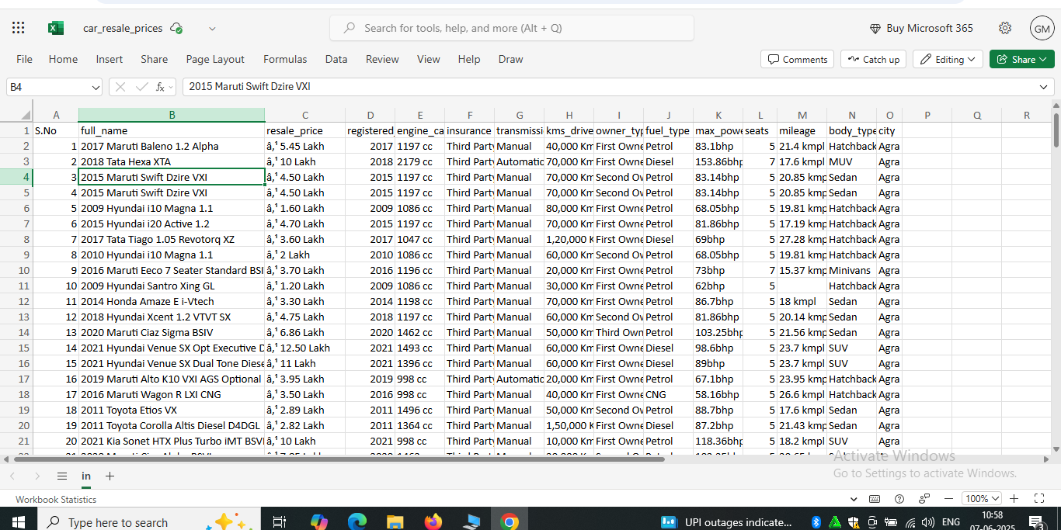

2. Remove Unknown Charecters in Resale Price

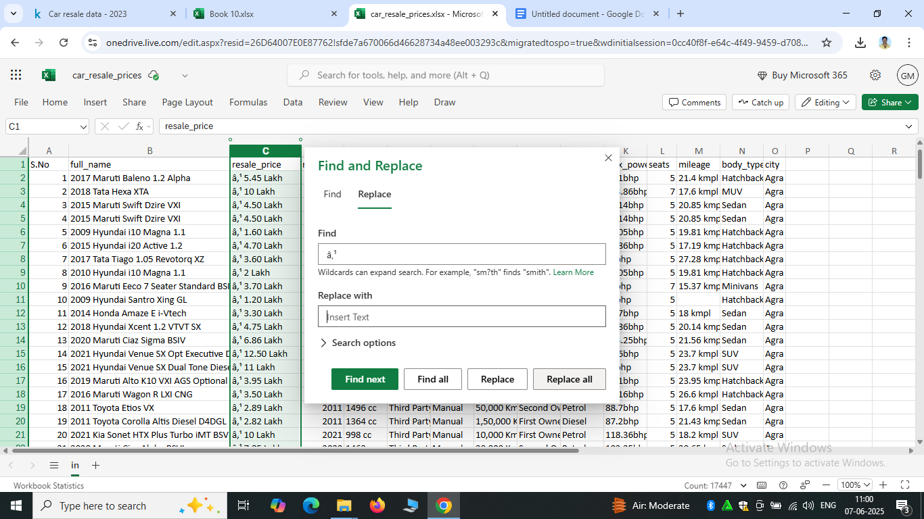

3.Use Flash Fill (Ctrl+E) Split Full Name and Register year

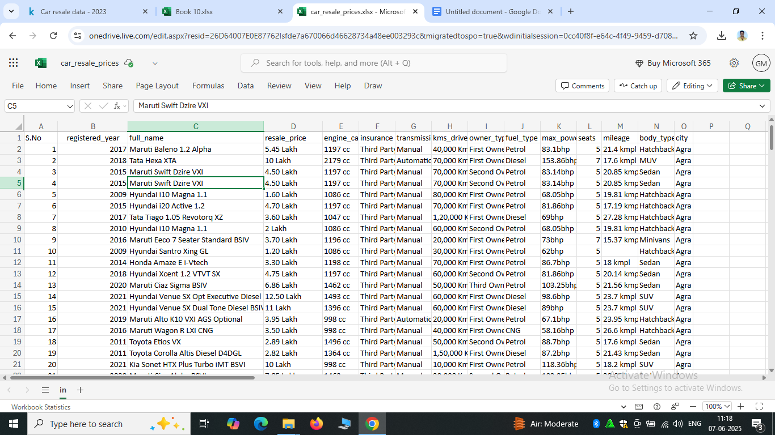

4. Resale Price change Amount in Lakh
Below 1 lakh divided by 100000 others manually correction and remove latters
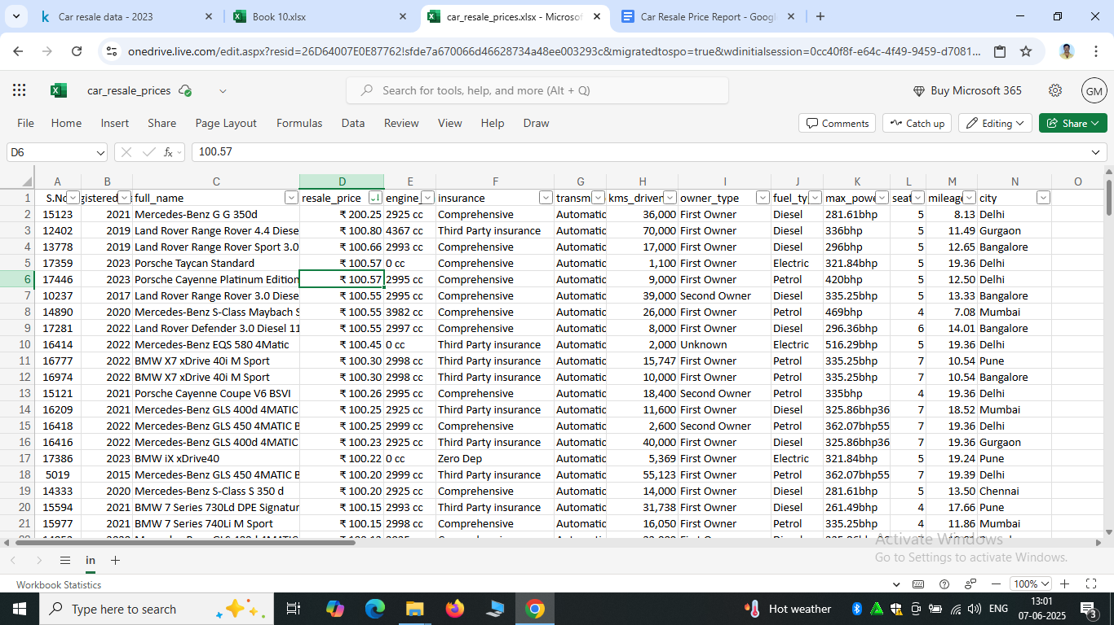

5. Split mileage row
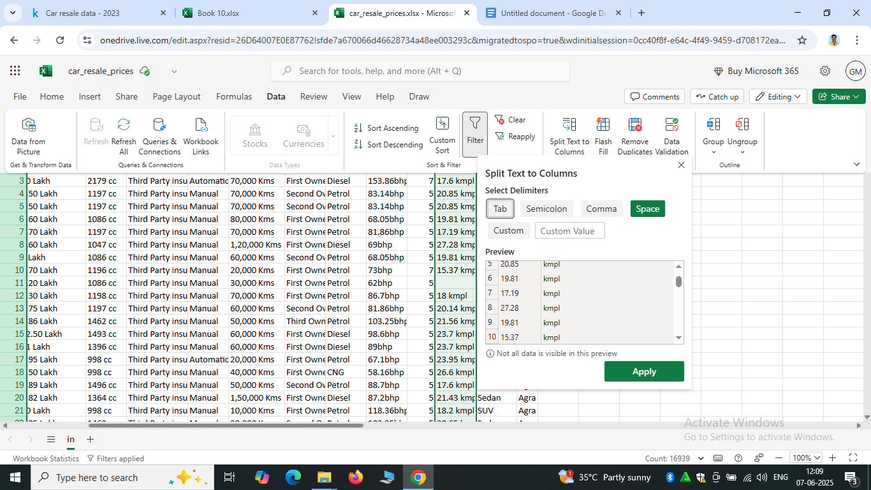

6.fill the empty cell for mileage and seat column
=IF(ISBLANK(M2),AVERAGE(M2:M17447),M2)
=IF(ISBLANK(L2),AVERAGE($L$2:$L$17447),L2)

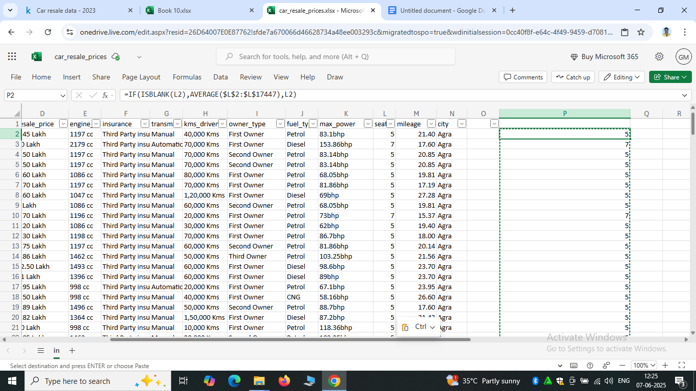

7.ill the empty cell for Insurance,max_power and owner type column
=IF(ISBLANK(F2),"Unknown",F2)
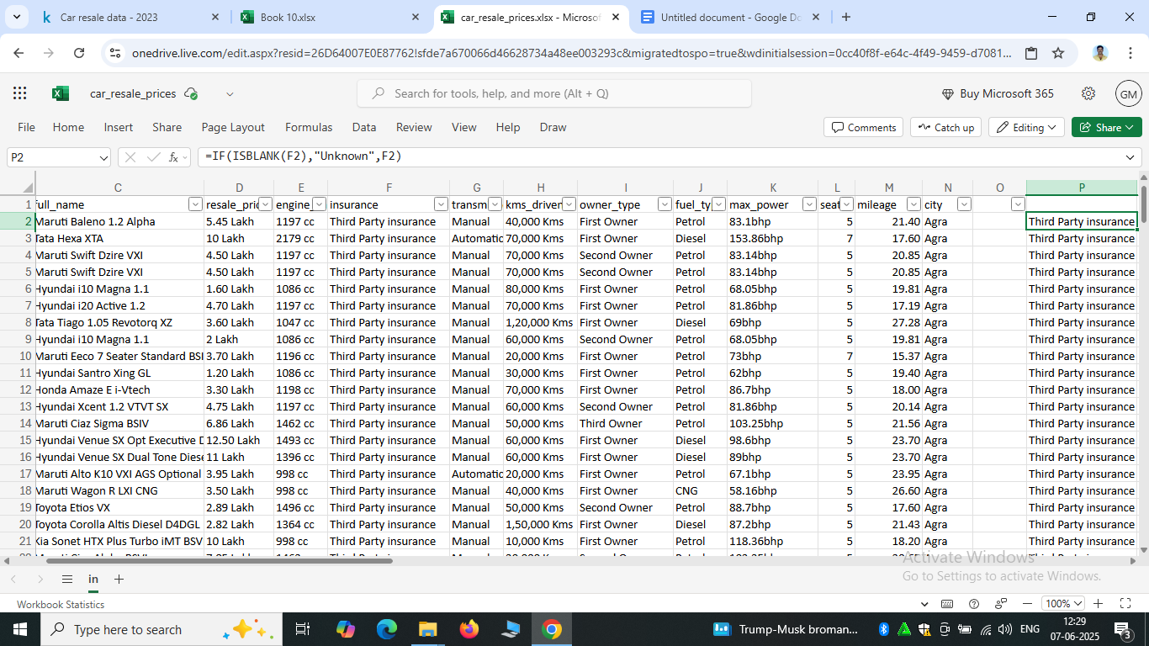
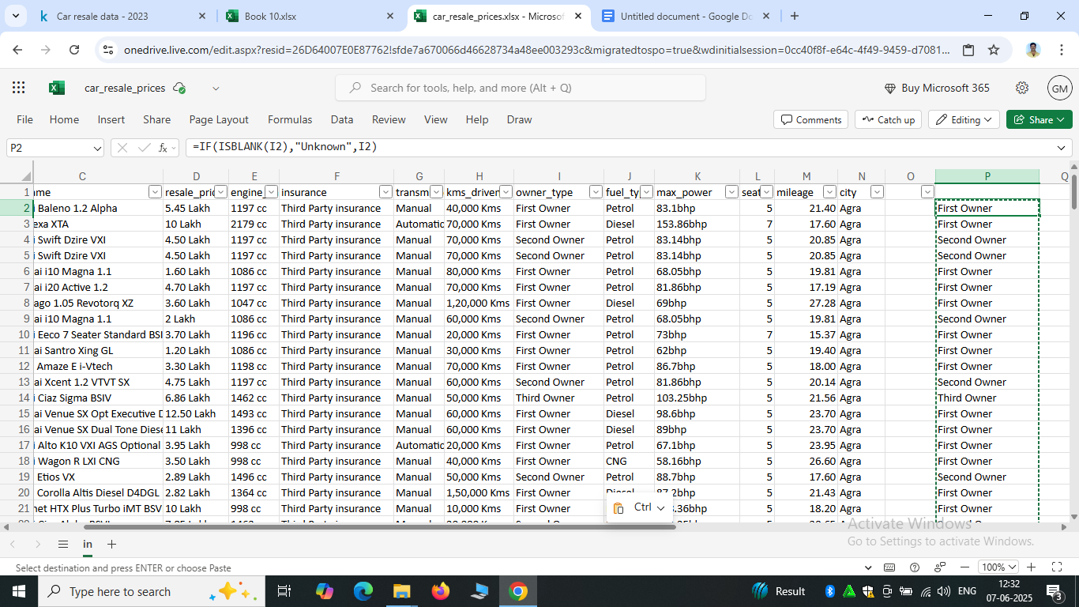

8. Clean data set
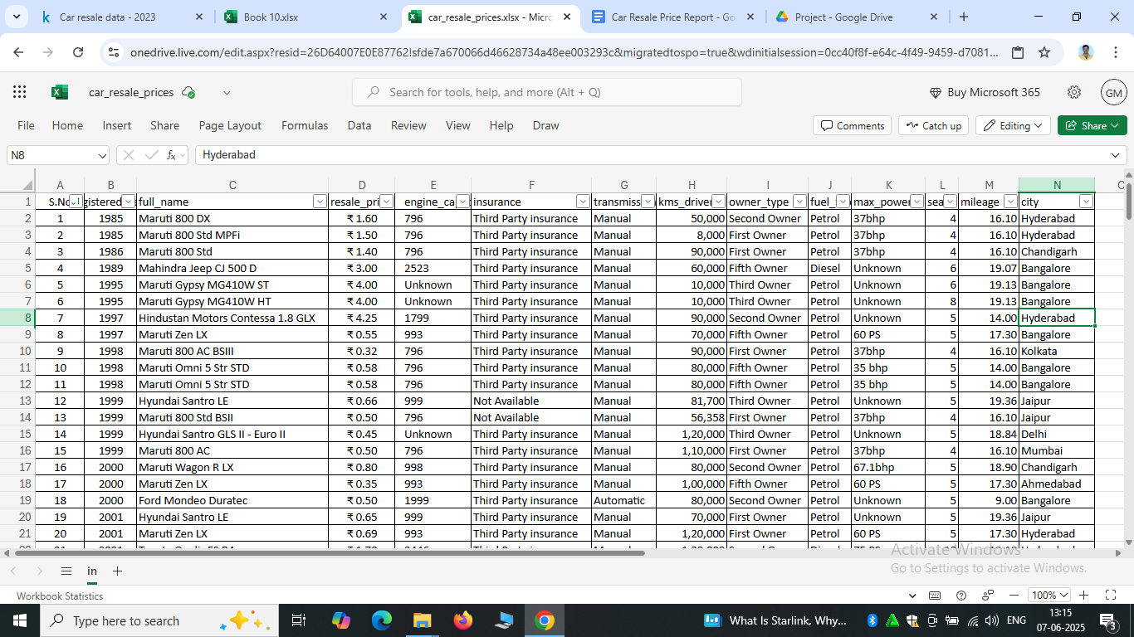

Create Visualization in Power BI
- Use Card Create Total Number Of Resales Car And Total Value

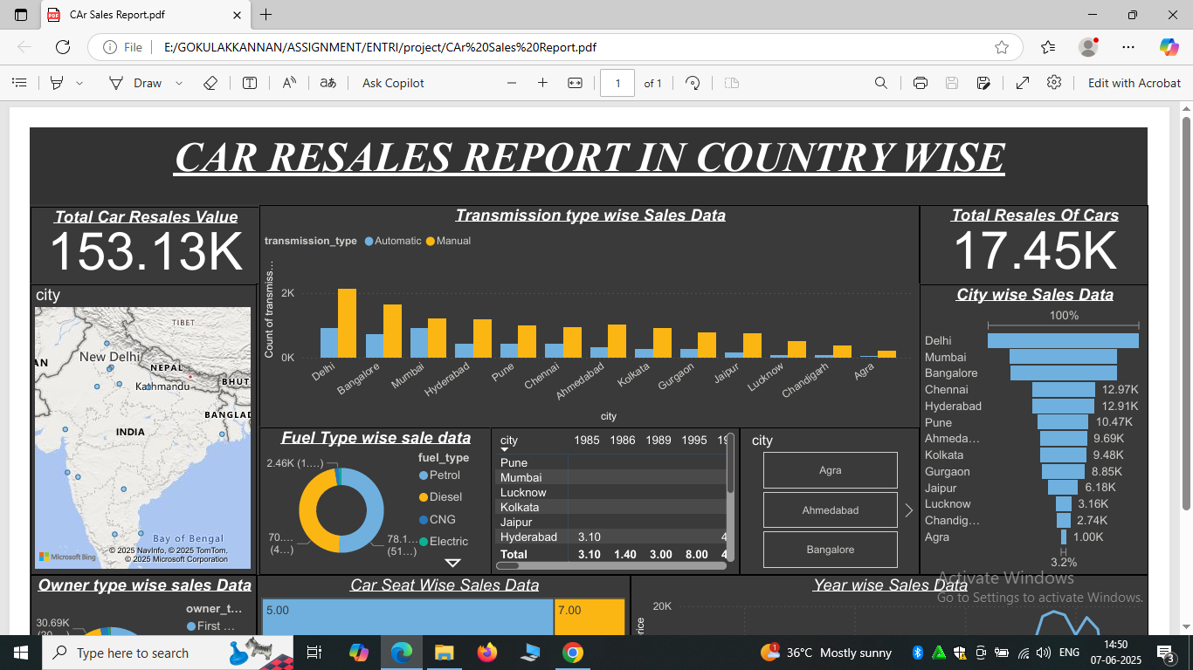

- Create Clustered Column Chart In Using Automatic And Manual Wise Sales Data In City

- Create Funnel Chart City Wise Sale Data
- Create Donut Chart Fuel Type Wise Sale Data

- Create City Wise Map Chart
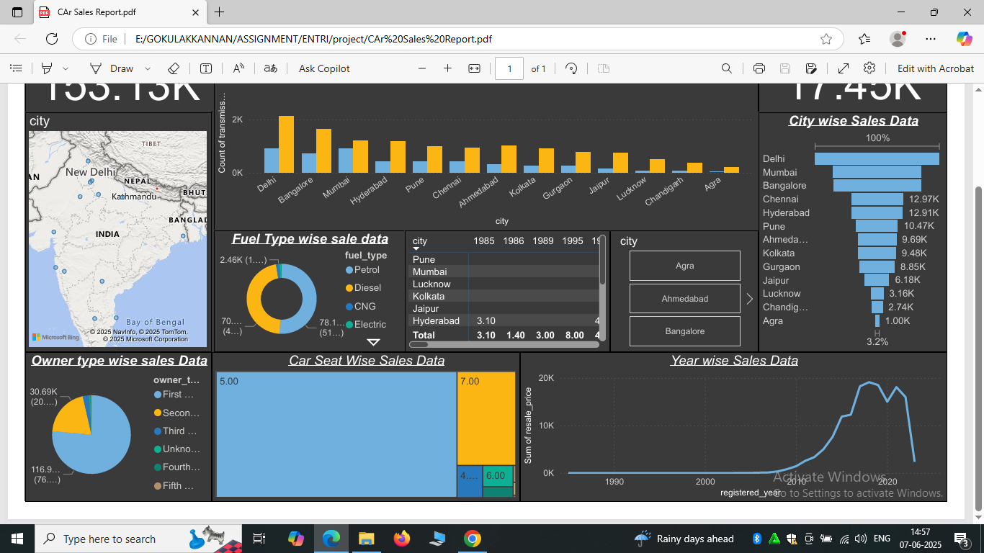

- Create Pie Chart Owner Type wise Sale Data
- Creat Tree Map Chart Car Seat Wise Sales Data Report

- Create Line Chart Year Wise Data
- Create Matrix Chart City And Year Wise

- Create Slicer City Wise

https://drive.google.com/file/d/1IEMkAzXQbLALTNaHAMQTeeI6rv8ISN3m/view?usp=drive_link
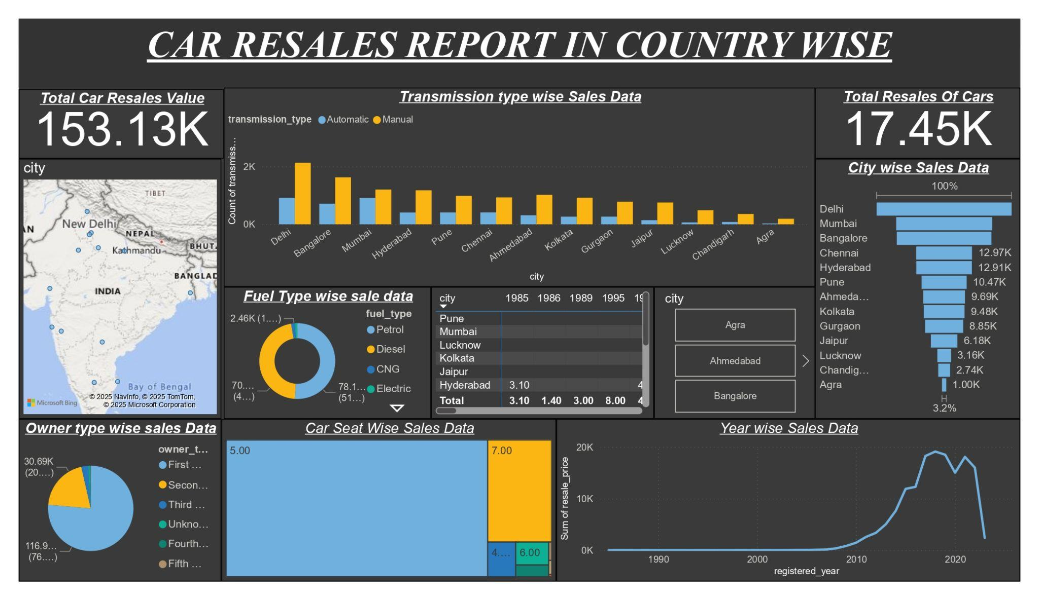

Thank You Sir

